Steps for the A4R_OpticoreMaster exe and storage exe

1.Create a folder in the C drive Program Files named A4R_OptiCore
2.Place these 2 scripts in that folder which created in the step1 “A4R_OptiCore”
3.Now download nssm (latest release) -> https://nssm.cc/download
4.Unzip nssm-x. xx
5.Unziped nssm-x.xx go to win64 folder and copy it into the C:\Program Files\A4R_OptiCore folder where already we have A4R_OpticoreMaster and storage exe's
6.open command prompt (run as administrator)
7.then paste cd C:\Program Files\A4R_OptiCore
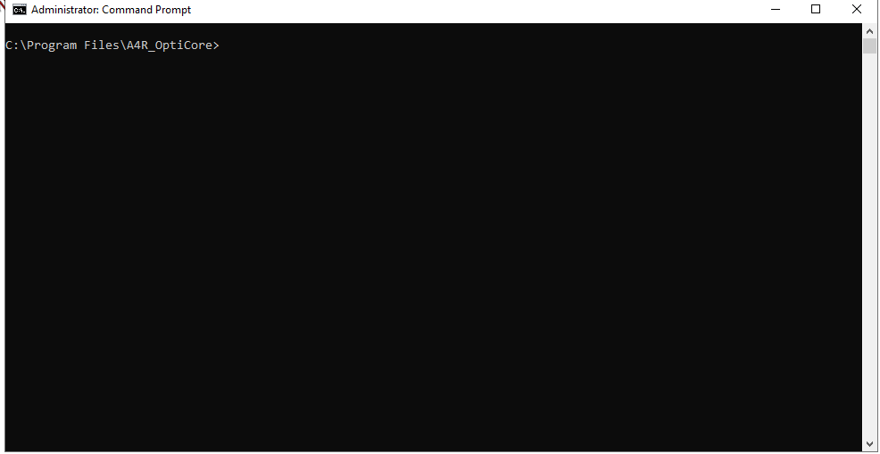

8.Now we create Services for A4R_StorageMonitor
9.write command -> nssm install A4R_StorageMonitor in open command prompt terminal

10.A dialog box appears (NSSM Service installer)
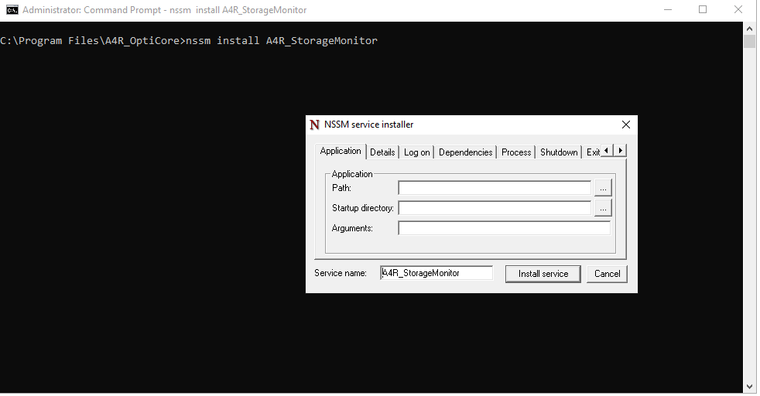
11.Then choose an Application Path C:\Program Files\A4R_OptiCore and click on the Storage exe
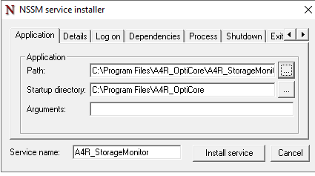
12.Then just click install service
13. Press Windows+R write services.msc
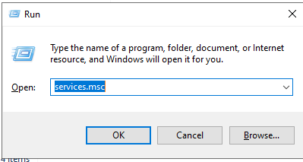

14.check the service will appear which we have created for the Storage
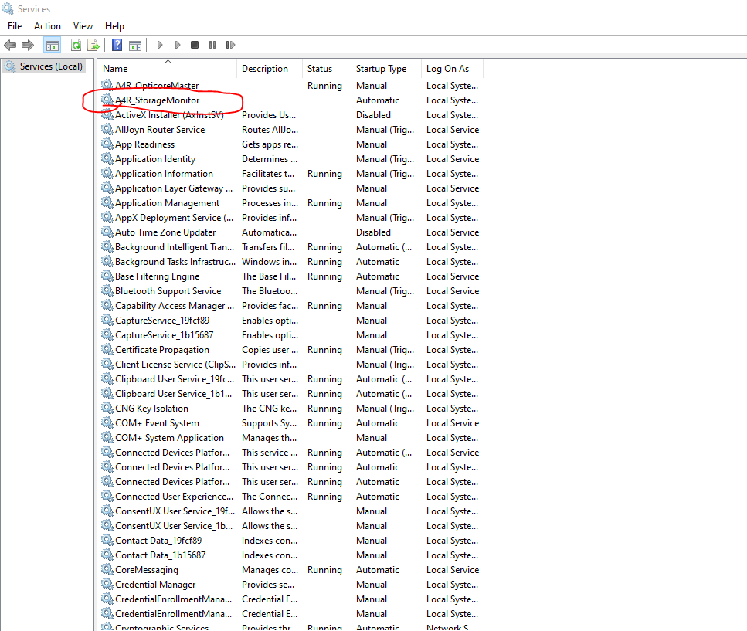

15.Service for the Storage is created now we proceed to A4R_OpticoreMaster exe
16 Repeat step 6 and step 7
- open command prompt (run as administrator)
- then paste cd C:\Program Files\A4R_OptiCore

17 Now we create Services for A4R_OpticoreMaster
18 write command -> nssm install A4R_OpticoreMaster in that opened command prompt terminal
19. A dialog box appears (NSSM Service installer)
20. Then choose an Application Path C:\Program Files\A4R_OptiCore and click on the A4R_OpticoreMaster exe
21 Repeat steps 12 and 13
-Then just click install service
- Press Windows+R write services.msc
22.Check for the A4R_MasterOpticore service
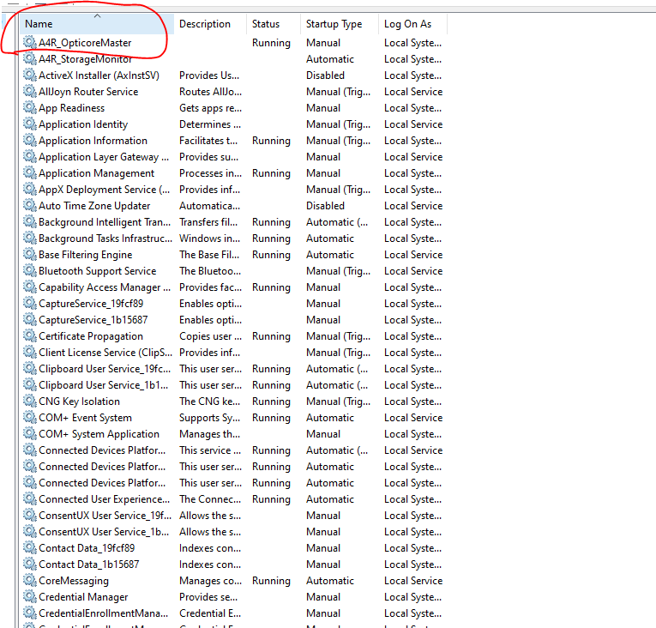

Steps to install the Resource monitor exe
(To be run for all the users for resource data collection user-wise)

1.Install python in the machine (for window activity ) -> https://www.python.org/downloads/
2. Run the python Installer as Administrator (this is critical for system-wide install)
NOTE: Python should be installed for all the users
3.Restart vdi.
4. Just verify it in the command prompt

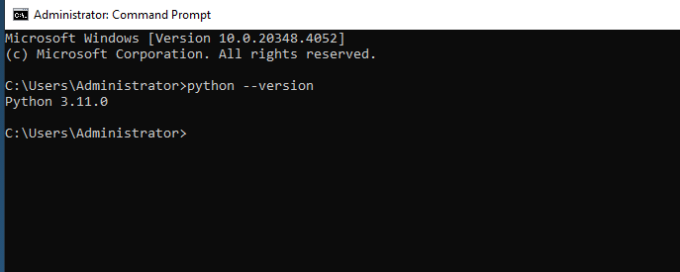
5. Install pywin32 using command -> pip install pywin3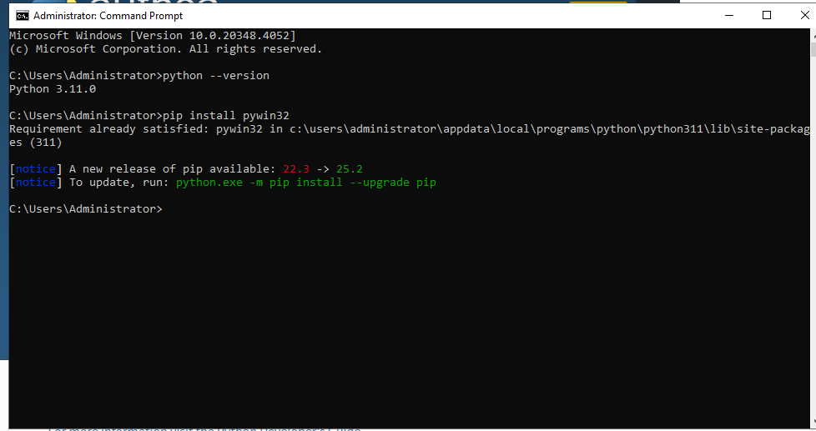
6. copy that script in the same C:/Program Files/A4R_Opticore

7.Setup using service
- Add to Registry (HKLM\Run)
- Open Registry Editor (regedit)
- Go to:
- Computer\HKEY_LOCAL_MACHINE\SOFTWARE\Microsoft\Windows\CurrentVersion\Run
- Right-click → New → String Value then named -> A4R_ResourceMonitor
- Value: “C:/Program Files/A4R_Opticore/A4R_ResourceMonitor.exe”

-----------------------------------------------------------------------------------------------------------------
Thank You

